
Year 10 -Pathway 2

Mini Test 5.1 -Semester 2

Statistics

Resources allowed: Calculator and 1 x A4 page one side

Name: ______________________ Class: ______ Time: 30 minutes Total Marks: ____/16

Show working and answers on this sheet. Show working in sufficient detail to support your answers. Incorrect answers without supporting reasoning may be allocated zero marks.

Question 1 (4 Marks)

Complete the calculations for the following measures of central tendency for the data set below:
1, 5, 5, 7, 8, 10
Mean:

Median:

Mode:
Range:

Question 2 (4 Marks)

Michael drinks the following number of cups of coffee each day in a week:

4, 5, 3, 6, 4, 3, 3

- What is the mean number of cups he has in a week?

- What is the mode for this data set?

- What is the median number of cups of coffee Michael drinks in a week?

- How many cups of coffee does he drink in a week?

Question 3 (3 Marks)

The results of a mathematics test are represented by this stem-and-leaf plot:

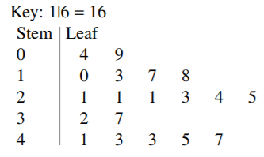

- Find the mean, median and mode.

Question 4 (5 Marks)

Sally is designing a website to advertise her services as a stuntwoman. She wants to be paid as much as possible and so is giving her average charge based on the last 8 films she has done. Calculate the mean, mode, median and range decide which would be the best charge to put on her website.

Earning per film: $1000, $8000, $7500, $3200, $5000, $8000, $600, $200

˜̴ End of Test ˜̴

